# *OPERATING SYSTEM LAB ASSIGNMENT – IV*

# 4ITRC2

Shreyansh Gupta

BE II Year

Information Technology ‘A’

# **Aim:**

To study and learn about various system calls

# **To perform:**

Comprehensive study of different categories of Linux system calls, categorized as

**1. Process Management System Calls**

Process management system calls allow the creation, execution, and termination of processes. Some key system calls include:

**fork()**

* Used to create a new process by duplicating the existing process.
* Returns the process ID of the child process to the parent and 0 to the child process.

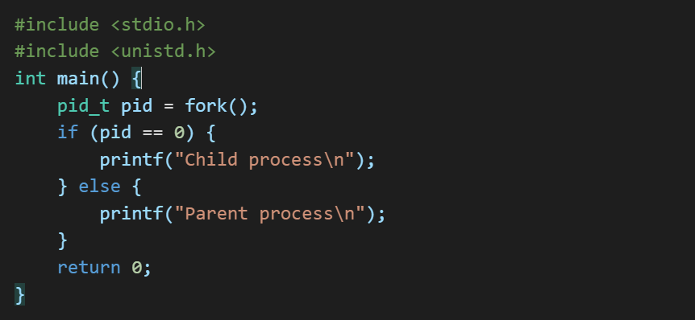

**exec()**

* Replaces the current process image with a new process image.

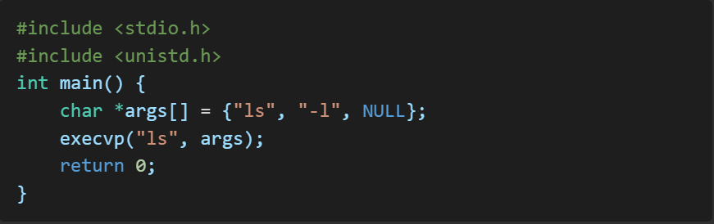

**wait()**

* Suspends execution until a child process terminates.

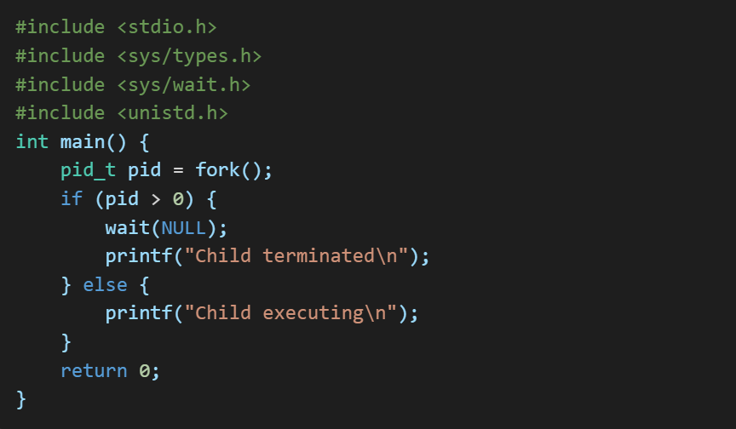

**exit()**

* Terminates the calling process.

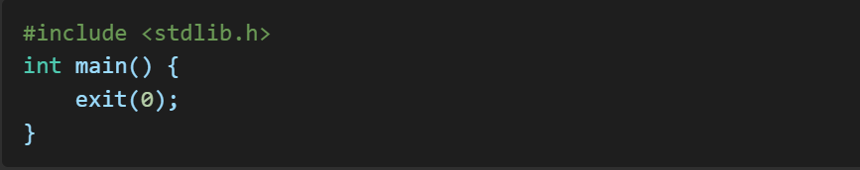

**2. File Management System Calls**

File management system calls enable interaction with the file system.

**open()**

* Opens a file.

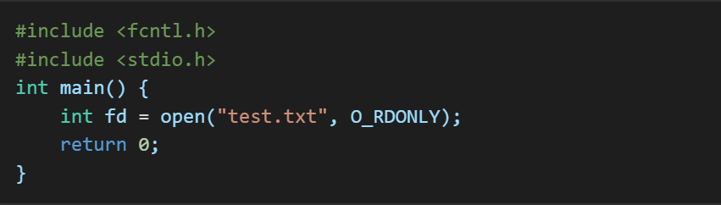

**read()**

* Reads data from a file.

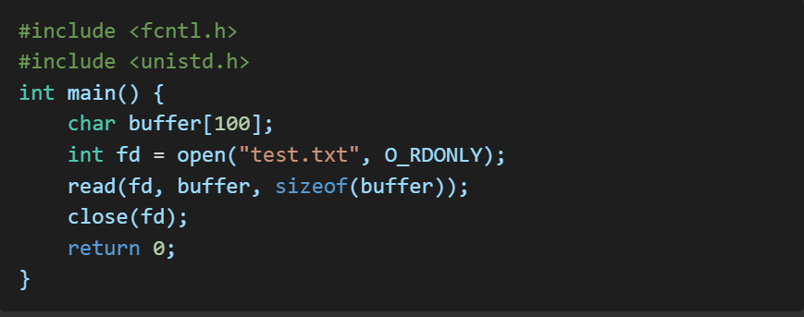

**write()**

* Writes data to a file.

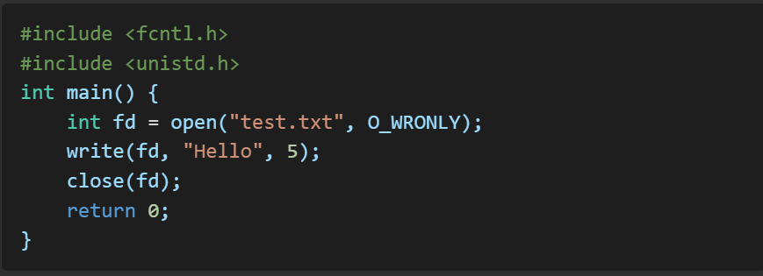

**close()**

* Closes an open file descriptor.

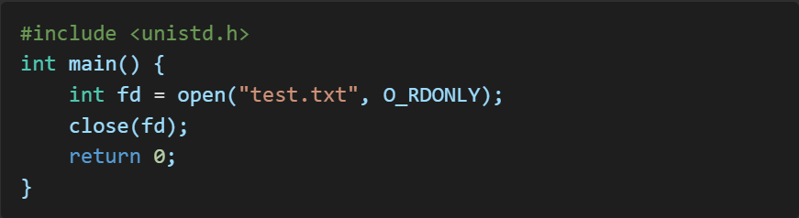

**3. Device Management System Calls -**

These system calls interact with hardware devices.

**read() and write()**

* Read and write operations work similarly to file management but for devices.

**ioctl()**

* Performs low-level device control operations.

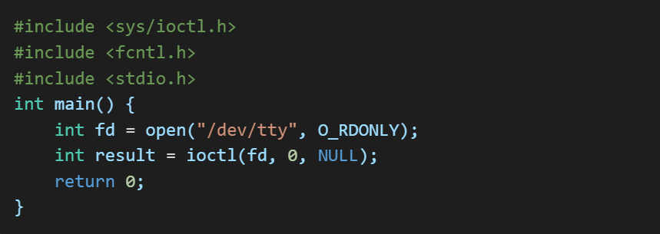

**select()**

* Monitors multiple file descriptors.

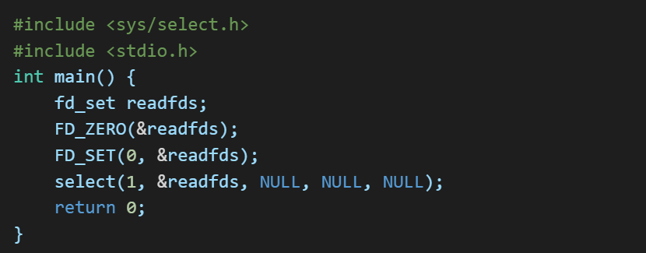

**4. Network Management System Calls -**

Network system calls enable communication over networks.

**socket()**

* Creates a socket.

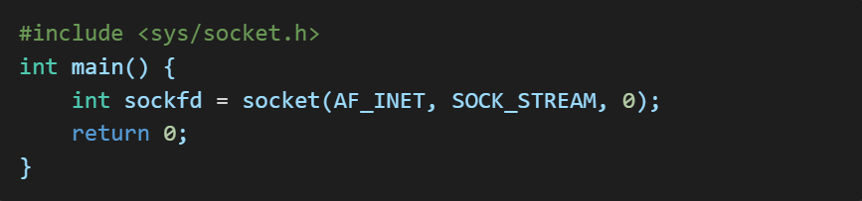

**connect()**

* Connects to a remote host.

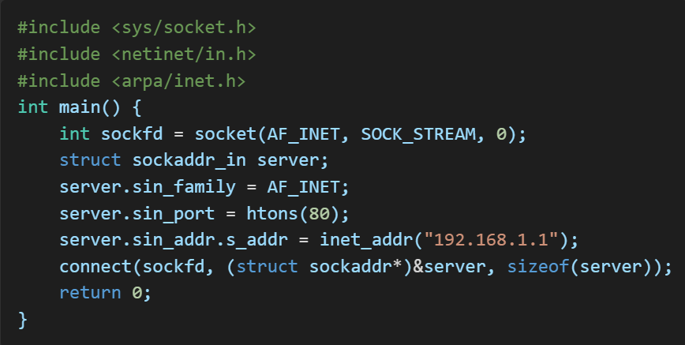

**send() and recv()**

* Send and receive data over a socket.

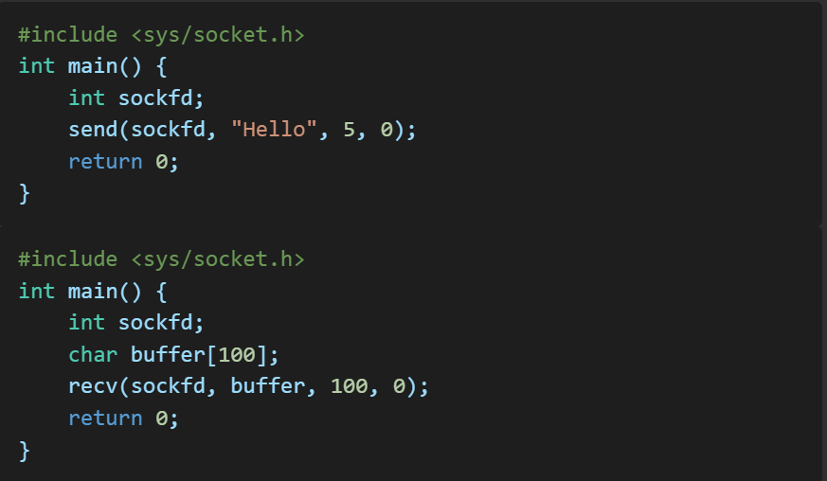

**5. System Information Management System Calls -**

These system calls retrieve system information.

**getpid()**

* Returns the process ID.

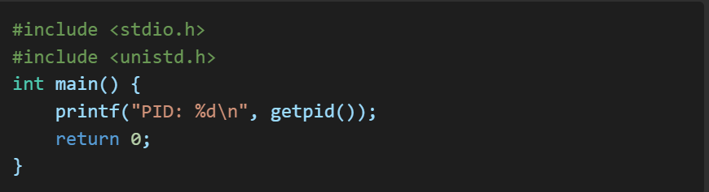

**getuid()**

* Returns the user ID.

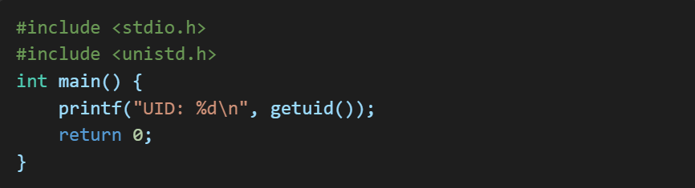

**gethostname()**

* Gets the system’s hostname.

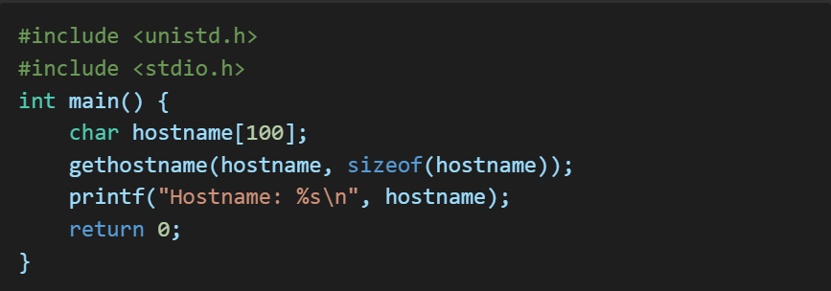

**sysinfo()**

* Retrieves system information.

